
HEFFRON PARK · MAROUBRA
RANDWICK NETBALL
The Weekly — Members’ Newsletter
FINALS SERIES — SEMI FINALS
2026 Winter Season
Hello Randwick Family,
This is the week the whole season has been building towards. Semi finals are here, and to every team that has fought its way through to our finals series — congratulations. You have earned your place. Play the netball you know how to play, look after each other on court, and enjoy every minute of it.
To the teams whose season finished last Saturday — thank you. You turned up week after week, in the cold and the wet, and you made this competition what it is. We hope to see every one of you back next year.
A reminder for finals: please arrive early and check the draw before you leave home.
THANK YOU DEBBIE — AND RESPECT FOR OUR UMPIRES
An enormous thank you to Debbie, who has coordinated every umpire across our semi finals. Rostering finals is no small job, and the fact that our games run on time with the right officials on the right courts is down to Debbie and the umpires who put their hand up.
We are asking every single person at Heffron this weekend to respect our umpires and our officials. Finals bring out the emotion in all of us, but nothing changes on court: it is just another game of netball. Our umpires are there so our girls can play.
Please remember the green armbands. If one of our umpires is wearing a green armband, she is under 18 — she is somebody's daughter, she is learning, and she deserves nothing but encouragement from the sideline.
OUR SPARKS ARE INTO THE GRAND FINAL
The UTS Randwick Sparks 23s are through to the 2026 IMB Bank Premier League Grand Final. After finishing the regular season on top of the ladder, our girls took out their semi final and go straight into the biggest game of the year.
Grand Final — Sunday 13 September, 5.00pm, Show Court, Netball Central, Sydney Olympic Park.
This is our team. Let us fill that stadium. Bring the family, bring the club, wear your Randwick colours and make some noise.
Randwick is right in the middle of this Grand Final day. Netball NSW has asked our Association to take on the grassroots roles on court, and our girls will be part of it:
• Guard of honour — a Randwick side forming up as the teams take the court
• Ball deliverers and our ball and mop crew — players aged 15 and over working alongside the officials
• NetSetGO medal presenters — twelve of our youngest players presenting the medals to the winning team
If your child is in NetSetGO and would love to present a medal, please contact Sasha, our NetSetGO Coordinator, at netsetgo@randwicknetball.com.au as soon as you can — places are limited.
FUEL THE GAME — OUR FIRST FREE SESSION IS MONDAY 14 SEPTEMBER
This is the one we have been working towards all season, and it is completely free. Through our Gatorade Fuel Tomorrow partnership, Randwick is bringing the very best in the game onto our court — for our players and our coaches at the same time.
Monday 14 September — Centre Court, with Paige Hadley. Paige is one of the finest mid court players in the country, and she will be taking our first session at the Heffron indoor centre.
The idea is a simple one. Our players learn the skill from someone who does it at the highest level, while our coaches sit courtside and learn how to teach it. Everybody walks away better.
Still to come: we are working on securing our goal shooting and goal defence sessions for Monday 21 and Monday 28 September, also at the Heffron indoor centre.
Free to every player and every coach at Randwick. Please register through our website: www.randwicknetball.com.au
SPARKS JUNIOR CLINICS — REP READY
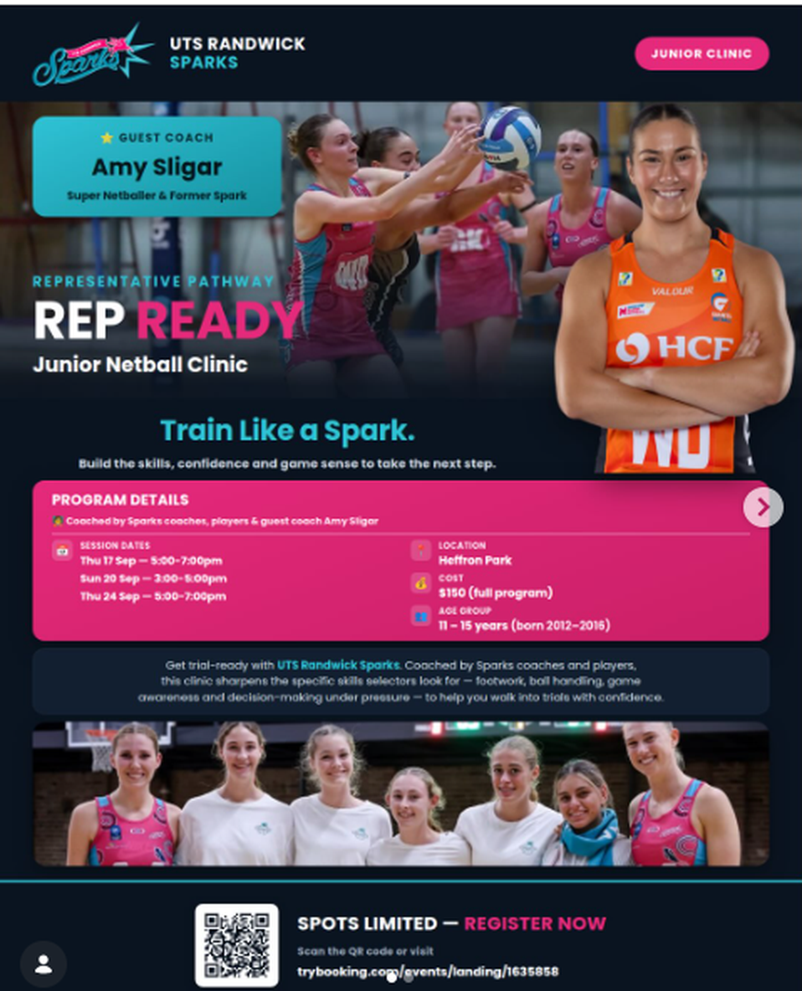 | Train like a Spark. The UTS Randwick Sparks are running their Rep Ready junior clinic at Heffron Park this September, and they have secured a guest coach to match the occasion — Amy Sligar, Siren #1, GIANTS player and former Spark.  • Thursday 17 September — 5.00pm–7.00pm  • Sunday 20 September — 3.00pm–5.00pm  • Thursday 24 September — 5.00pm–7.00pm
Heffron Park · $150 for the full programme · 11–15 years (born 2012–2016). Spots are limited. Register at trybooking.com/events/landing/1635858
JUNIOR REP TRIALS — SAVE THE DATES
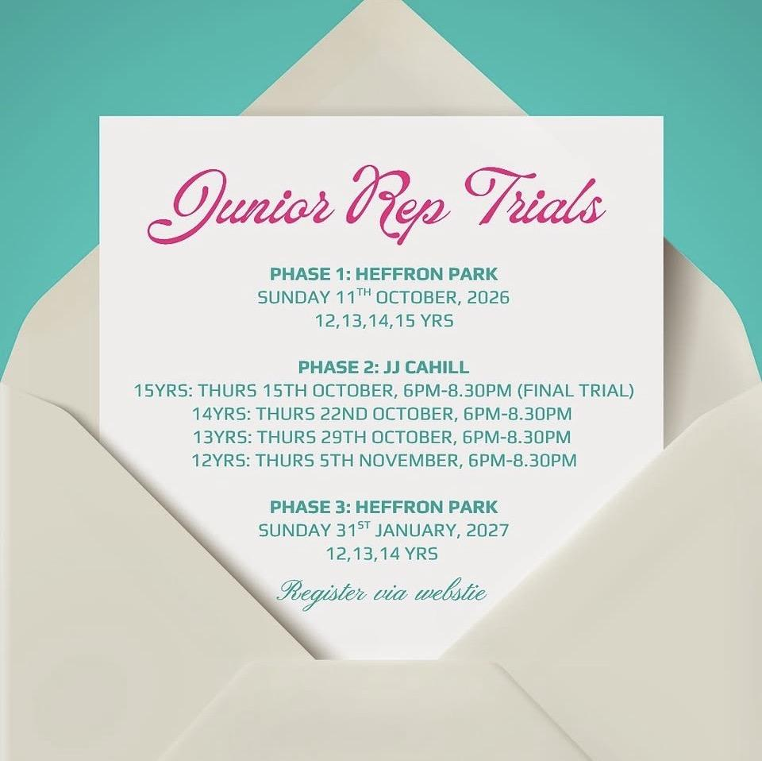 | Our 2027 Junior Representative trials are locked in. Put these dates in the family calendar now.  Phase 1 — Heffron Park. Sunday 11 October 2026, for 12s, 13s, 14s and 15s.  Phase 2 — JJ Cahill, 6.00pm–8.30pm. 15s Thu 15 Oct (final trial), 14s Thu 22 Oct, 13s Thu 29 Oct, 12s Thu 5 Nov.  Phase 3 — Heffron Park. Sunday 31 January 2027, for 12s, 13s and 14s.
Registrations are through our website: www.randwicknetball.com.au
NEXT STEP COACH U — OCTOBER AND NOVEMBER
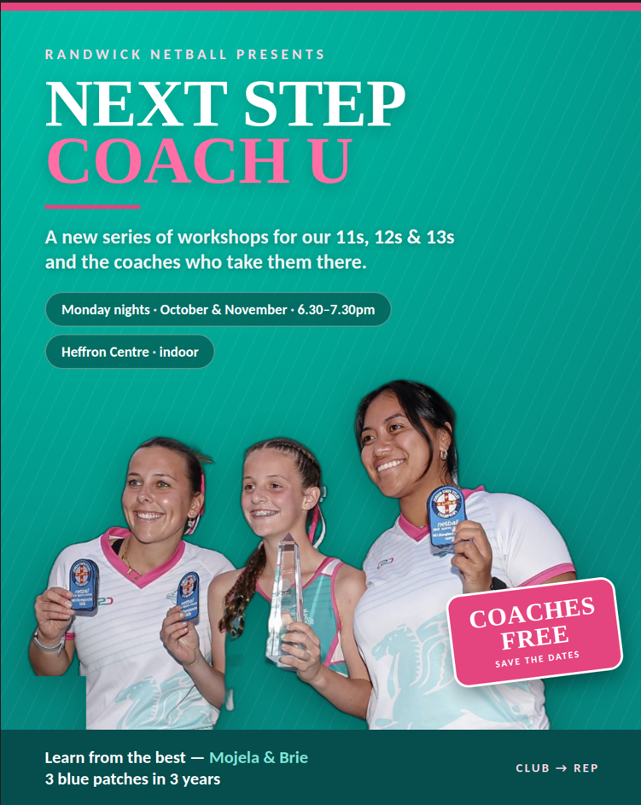 | Something new, and something we are very excited about. Next Step Coach U runs on Monday nights through October and November at the Heffron Centre, and it is built for our 11s, 12s and 13s — and just as much for the young coaches who work with them.  It will be led by Mojela and Brie, who have taken our girls to three State blue patches in three years of coaching. There is nobody better placed to teach this.
Two things happen in every session. Our players pick up the skills that bridge the gap between club and representative netball, and our coaches get the inside knowledge on how to run a training session properly.
Mondays through October and November · 6.30pm–7.30pm · Heffron Centre.
Please mark your diaries now. Full details will follow shortly, but places will fill quickly.
So much is happening on the coaching side of Randwick — and almost all of it is free to our members. None of it would be possible without Gatorade, and we are enormously grateful for that partnership. If you have not signed up to Coach Hub yet, it takes two minutes.
CLARITY POOLS SPRING SUPER SHOT COMP — ENTRIES OPEN
 | Nominations are open. Winter is nearly done, so let us talk about spring. The Clarity Pools Spring Super Shot Comp is social netball for all skill levels, Wednesday nights at Heffron Park, running 14 October to 2 December.  Grab a team of friends, or come on your own and we will find you one. Our thanks again to Clarity Pool Management, our naming sponsor.
Team entries are open now: randwicknetball.com.au/springr-super-shot-competition-2/
Three cheers for our opponents. Three cheers for our umpires. One cheer for us. And a handshake at the end.
Kindness Wins.
Jenny Morrissey
President | Randwick Netball Association
WITH THANKS TO OUR WONDERFUL SPONSORS
