
HEFFRON PARK · MAROUBRA
RANDWICK NETBALL
The Weekly — Members’ Newsletter
ROUND 15 · FINAL ROUND
2026 Winter Season
THIS WEEK’S MATCH DAY SPONSOR

Proudly on court with Randwick Netball at Heffron Park this Saturday.

Hello Randwick Family,
A very warm welcome to CESA Electrical Services, our match day sponsor this Saturday. CESA are licensed electrical contractors working right across Sydney, and they have chosen to put their support behind community netball at Heffron Park. When you next need an electrician — at home, at work or for your building — please think of them first. Our sponsors are the reason we can keep our fees low and our programmes growing.
And what a Saturday it is. This is the final round of our 2026 Winter Season — the last ordinary Saturday before finals. There is a lot in this edition, so please read it through.
THAT’S A SEASON — THANK YOU, RANDWICK
Around 200 teams. Thousands of you through the gates at Heffron every Saturday — in the cold, in the wet, and in some glorious winter sunshine.
To our players — thank you for turning up, having a go and looking after each other. To our coaches and team managers, who plan, cajole, encourage and drive the car — thank you. To our umpires, many of them still at school, who stood on court every single week — thank you, and thank you for wearing it so well when it was not easy.
To our scorers, timekeepers, canteen volunteers, control room crew, convenors and committee — none of this happens without you, and almost none of it is paid. To our clubs, thank you for looking after your people so well this season.
And to our families — the ones doing the early starts, the orange quarters, the washing and the long drives — you are the reason this Association works. We hope your season was a fun-filled one. We are very proud of all of you.
RNA FINALS SERIES | PLEASE READ
Congratulations to every team who has earned their place in the RNA Finals Series. Finals days are the biggest days on our calendar, so we are asking everyone — players, coaches, officials and supporters — to take a few minutes to read through the game management procedures below. These are in place to help our games run smoothly and to let our players, umpires and officials focus on the game.
SCORER & TIMEKEEPER
- Home team (listed first): 1 scorer (PlayHQ)
- Second team: 1 timekeeper (paper scorecard)
- Only cumulative injury/blood time is added to game time. No other “time” calls are added.
SCORECARDS
Umpires will bring scorecards to the courts. The winning team returns the scorecard to the Control window at the end of the game, and PlayHQ scoring must be submitted on completion of the game. Teams remain responsible for making sure all scorecard information is completed correctly, including player sign-ons and scores.
PLAYER SIGN-ON
All players must sign the scorecard in full — no ticks, no initials. The scorecard is the official record and is checked by our Competition Coordinators. Incorrect sign-ons may result in the Ineligible Player rule and associated penalties being applied.
SCORERS
- Both officials must stand together in the allocated space on the sideline, in line with the centre circle, and both must sign the scorecard in the correct section.
- Scorers must agree on and record the final score before handing the scorecard in and submitting in PlayHQ.
- Only one designated person from each team may approach the scorers during an interval to check the score. Coaches are not permitted to approach the scorers during the game.
- Any suspensions, send-offs or incidents are to be recorded on the back of the scorecard.
TIMEKEEPER
The timekeeper must:
- Record all injury/blood stoppages only, on a mobile phone, and make sure the scorers record them
- At three-quarter time, advise the umpires and both teams of the additional time to be added to the fourth quarter
- Advise the nearest umpire when 15 seconds remain
- Advise the nearest umpire when the additional time has been completed
UMPIRES
- Two neutral umpires will be allocated to each finals game.
- Umpires must sign on and attend a briefing in Control 15 minutes prior to each game.
- Reserve umpires will be stationed in Control in the event of umpire injury.
- Umpires under 18 years are required to wear green armbands. These reflect age, not skill. Please remember this is someone else’s child — respect them as you would your own.
NO OFFICIALS = NO GAME
Both officials must be present before a game can start, and must remain in position for the whole game, including breaks and stoppages. Officials must be capable of performing their duties, must remain together in the designated officials’ area, and must not engage with players, coaches or spectators. Officials cannot be changed during a game without the approval of an RNA Executive member, or due to injury.
DRAWN GAMES — SEMI-FINALS & PRELIMINARY FINALS
If a game is drawn at full time, extra time is played:
- The bench or spectator notifies the Umpires Committee at Control, and the timer sets their clock.
- Two 5-minute halves are played, with teams changing ends after 5 minutes without an interval.
- No substitutions or positional changes are permitted before extra time begins. Rolling substitutions may be used once extra time starts.
- Normal stoppage procedures apply during extra time — injury/blood time only.
- If still drawn after the second 5-minute half, a one-minute drink break applies.
- Teams again swap ends, reset to a centre pass, and play continues uninterrupted until one team is two goals up. The scorer advises the nearest umpire to end the game.
DRAWN GAMES — JUNIOR GRAND FINALS
There is no extra time in our junior grand finals. Injury and blood time only is added to game time. If the scores are level at the end of full time, the teams are declared joint premiers and both teams receive premiership awards.

SPECTATORS
- Please remain in the designated spectator areas, to the left-hand side of the controlling umpire for that half.
- No spectators are permitted on the baselines, and anyone in these areas will be asked to move.
- For everyone’s safety, children should not be playing or running around near the courts while games are underway, and spectators are asked not to walk through play or congregate near our umpires.
Please speak with your club if you have any questions. Let’s all do the right thing.
❤ Enjoy the games ❤ Respect the umpires ❤ Respect the coaches’ decisions ❤ Cheer loud and proud
UTS RANDWICK SPARKS — INTO THE PREMIER LEAGUE FINALS
 | Our Under 23s have clinched the minor premiership — out of a four-way tie for first place — and go into the 2026 IMB Bank Premier League finals series in the box seat. A wonderful effort from the whole squad and their coaching staff.  Our Opens finished the season 5th, missing finals by a single win with it coming down to the very last game. Heads high — that is a tight competition and they were right in it to the end.

SEMI-FINALS — WEDNESDAY 2 SEPTEMBER, NETBALL CENTRAL
23U Major Semi-Final: UTS Randwick Sparks v Sutherland Stingrays — 8.45pm, Show Court.
Doors open 6.00pm. Come and make some noise for our girls.

If the Sparks reach the Grand Final on Sunday 13 September, Netball NSW invites our grassroots community into the day — and we would love to fill every spot from within Randwick:
Ball deliverer (one per team) · Ball/mop people (two per team, aged 15+) · Guard of honour (a rep team to form the tunnel) · NetSetGO medal presenters (at least 12 of our NetSetGO players). Complimentary tickets come with every role — including one for a parent alongside each medal presenter.
Register your interest at admin@randwicknetball.com.au with your child’s name, age and preferred role.
ONE YEAR TO GO — OUR GIRLS ON SYDNEY HARBOUR
 | 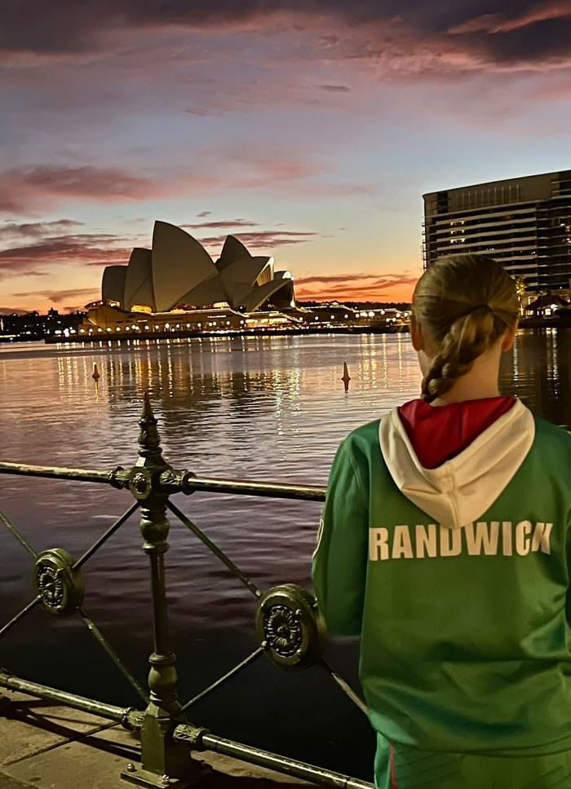
Our Randwick girls at the Netball World Cup Sydney 2027 One Year To Go launch on Sydney Harbour.
What a thing to be part of. This week a group of our Randwick girls represented the Association at the Netball World Cup Sydney 2027 “One Year To Go” launch on Sydney Harbour — where a floating netball court was set up against the Harbour Bridge to mark one year until the world’s best arrive.
They stood alongside Diamonds players, Jamaican international Shamera Sterling-Humphrey, and senior government and Netball Australia figures. Organisers used the day to announce their ambition for more than 200,000 attendees across 64 matches — which would make Sydney 2027 the most attended Netball World Cup in history.

NETBALL WORLD CUP SYDNEY 2027
25 August – 5 September 2027 · 16 nations · 12 days · 1 trophy
Register your interest now at nwc2027.com to be first in line when tickets go on sale.

Eight nations have already qualified, with another eight to be decided through regional qualifiers across 2026. Our girls will be somewhere in that crowd in twelve months’ time — and some of them, one day, may well be on the court.
RANDWICK SPRING SUPER SHOT COMP — GET YOUR TEAM IN
The season may be finishing, but netball at Heffron is not. Our Randwick Spring Super Shot Comp, proudly sponsored by Clarity Pool Management, is social netball for all skill levels — juniors, inters, seniors and NetSetGO — on Wednesday nights at Heffron Park, 14 October to 2 December.
- Grab a team of friends, or come on your own and we will find you one.
- Every player receives an end-of-comp participation gift.
Team entries are open now: randwicknetball.com.au/springr-super-shot-competition-2/
A big thank you to Clarity Pool Management for coming on board as our naming sponsor — it is appreciated more than you know.

Three cheers for our opponents. Three cheers for our umpires. One cheer for us. And a handshake at the end.
Kindness Wins.
Jenny Morrissey
President | Randwick Netball Association
WITH THANKS TO OUR WONDERFUL SPONSORS
