
Team Captain Handy Hints to Register Your Team
Registration Opens: Monday, 1 December 2025
Registrations Close: 5pm Friday, 30 January 2026

- Players must register via the Play HQ application link that will be initiated by the Team Captain.
- Team Captains must ensure that they have submitted their team registration form on or before close date, ensuring all players have registered in PlayHQ.
- Team Registration Form Available by clicking here!!

How do Team Captains initiate their team’s name link for registration.
Step 1:
NetSetGo Teams only (7, 8 & 9 Years Only) – click here take you to the “Get started” NetSetGo page
All Other Teams (not NetSetGo) – click here to get the “Get started” for Junior, Inter & Senior Competition.

Step 2:
Log in with your Play HQ Account or if no account, “Create an account”
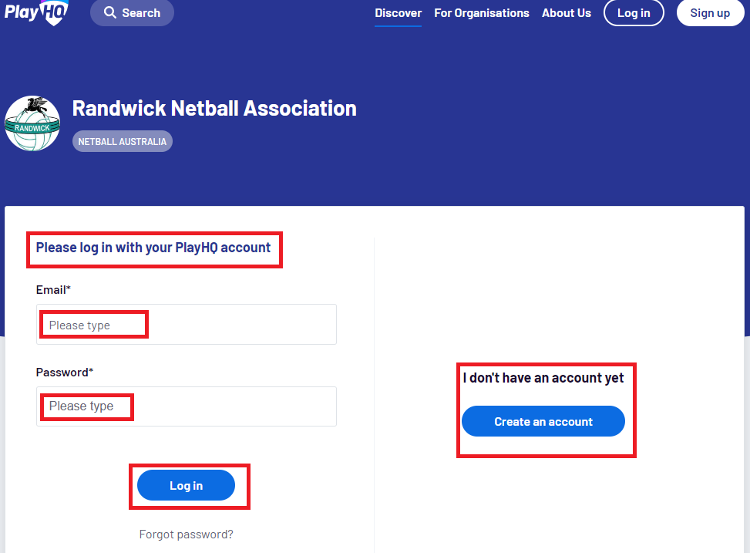

Step 3:
Create your Team Details then continue:
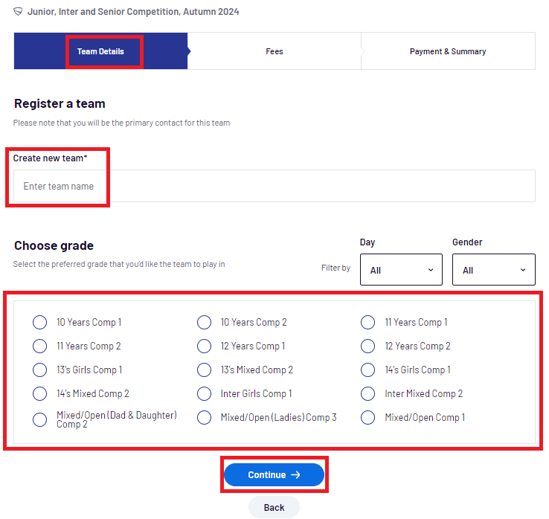
Step 4:
NIL fee to register your team’s name. Ensure you select the terms and conditions and move to the final stage wherein you will then be generated your team link.
The team link will be emailed to you for which you then provide to your team players to register and pay their fees.
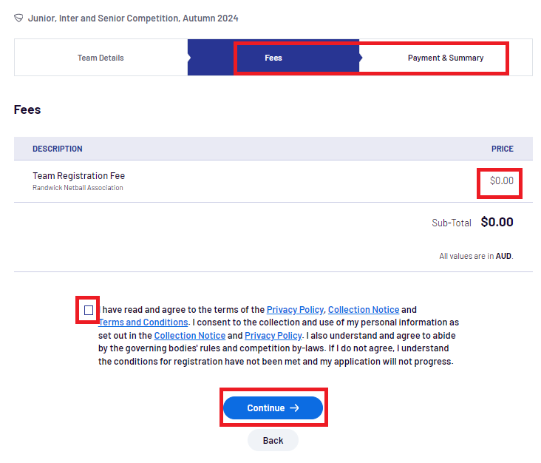
Step 5:
Ensure all team members have registered and Team Captain must complete the Team Registration Form Available by clicking here and return to the Senior Competition Coordinator email by 5pm, Friday, 30 January 2026; seniorcomp@randwicknetball.com.au

Are you or any of your players interested in Umpiring during the 2026 Summer Super Shot Competition? Please send your expression of interest here!!
We look forward welcoming your team participating in our 2026 Summer Super Shot Competition!!

